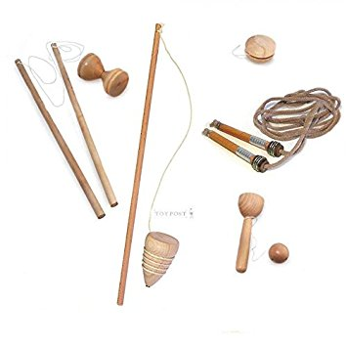

Maths

* Number and place-value
* Fractions
* Statistics
* Four operations
* Solving word problems

RE

* Christianity – leaders and teachers

Music

* What’s the score – exploring instruments and symbols

Geography

* Sunhats or umbrellas? – looking at different weather

Literacy

* Story in a familiar setting
* Letter writing
* Poetry

Our topic this term is:

History

* Victorian children at play

**Victorians – toys**

PE

* Ball skills – netball
* Athletics

Computing

* We are storytellers – producing a talking book

Art/D&T

* Colour chaos – exploring colours

Science

* Scientists and inventors – we will become scientists!

French

* Family