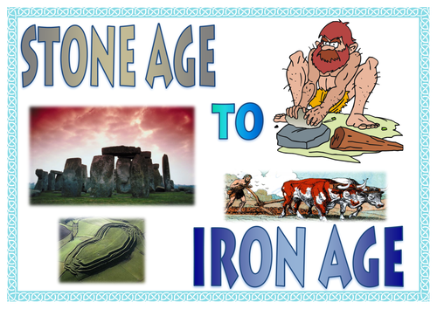

PSHE:

Identifying achievements, moving on, coping with change

Science:

Evolution and Inheritance:

* recognise that living things have changed over time and that fossils provide information about living things that inhabited the Earth millions of years ago
* recognise that living things produce offspring of the same kind, but normally offspring vary and are not identical to their parents
* identify how animals and plants are adapted to suit their environment in different ways and that adaptation may lead to evolution.

Electricity:

* associate the brightness of a lamp or the volume of a buzzer with the number and voltage of cells used in the circuit
* compare and give reasons for variations in how components function, including the brightness of bulbs, the loudness of buzzers and the on/off position of switches
* use recognised symbols when representing a simple circuit in a diagram.

Geography:

* name and locate counties and cities of the United Kingdom, geographical regions and their identifying human and physical characteristics, and understand how some of these aspects have changed over time

History:

* Changes in Britain from the Stone Age to the Iron Age

RE:

* Humanism ~ Happiness
* Christianity ~ Eucharist
* Islam ~ Beliefs and Questions

Music:

* play and perform in solo and ensemble contexts, using their voices and playing musical instruments with increasing accuracy, fluency, control and expression
* use and understand staff and other musical notations

PE:

* use running, jumping, throwing and catching in isolation and in combination
* play competitive games, modified where appropriate [for example, badminton, basketball, cricket, football, hockey, netball, rounders and tennis], and apply basic principles suitable for attacking and defending
* develop flexibility, strength, technique, control and balance [for example, through athletics and gymnastics]
* take part in outdoor and adventurous activity challenges both individually and within a team

Art/DT:

* Clay models ~ to improve their mastery of art and design techniques, including sculpture with a range of materials [for example clay]
* Making buzzer games ~ design, make ,evaluate and develop technical knowledge

ICT:

* Presenting Information ~ select, use and combine a variety of software (including internet services) on a range of digital devices to design and create a range of programs, systems and content that accomplish given goals, including collecting, analysing, evaluating and presenting data and information

French:

Develop understanding of oral and written language ~ holidays and rooms in the house

Literacy:

* Recommend books to others
* Making comparisons within and between texts
* Identify how authors use language
* Using dictionaries to check spelling and meaning of new words
* Plan, draft and evaluate writing, considering purpose and intended audience
* Handwriting and presentation
* Spelling
* Developing punctuation used in writing
* Formal writing
* Understanding grammatical terms
* Instructional, explanatory, creative and informative writing

Maths:

* Problem solving and reasoning
* Written methods of calculation
* Ratio and proportion
* Describing position and direction in the four quadrants