[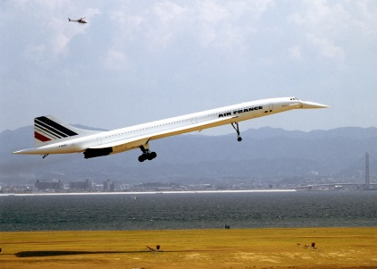](https://www.google.co.uk/url?sa=i&rct=j&q=&esrc=s&source=images&cd=&ved=0ahUKEwjoxa6m49LLAhUI7RQKHa7RAowQjRwIBw&url=https://commons.wikimedia.org/wiki/File:Concord_1_94-9-5_kix.jpg&psig=AFQjCNGfaW162SwOtawunHlmez4UIGXicg&ust=1458683940719211)[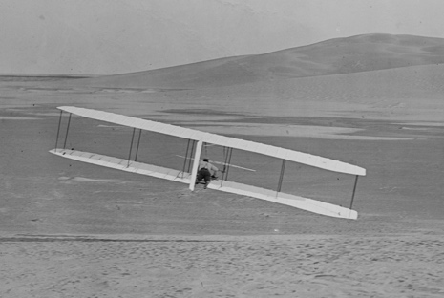](https://www.google.co.uk/url?sa=i&rct=j&q=&esrc=s&source=images&cd=&cad=rja&uact=8&ved=0ahUKEwjDq4Pr4tLLAhUGaRQKHXcLBbwQjRwIBw&url=https://en.wikipedia.org/wiki/Wright_brothers&psig=AFQjCNHyDBXdbeS-UNtCILjDj50167cNpA&ust=1458683795381020) [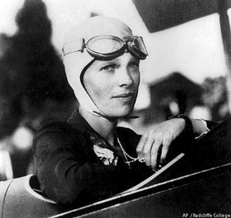](http://www.google.co.uk/url?sa=i&rct=j&q=&esrc=s&source=images&cd=&cad=rja&uact=8&ved=0ahUKEwjV4cX14dLLAhXJwxQKHaiPCWIQjRwIBw&url=http://www.holidaysmart.com/1ameliaearhart.htm&psig=AFQjCNFfE5Tf-ek3l7xDabDaWuPIeqv1cA&ust=1458683557843182)

PSHE: Good to be me

* Feelings; surprised, relaxed
* Discuss the things I am good at
* Hiding my feelings
* Being assertive
* Think before I act

French:

* On Mange
* Les vetements

Music:

* BBC 10 pieces – Holst Planets

ICT:

* Stop Motion animation

RE:

* What do Christians believe when they talk about the Kingdom of God?
* What symbols and stories help Jewish people remember their covenant?

PE:

* Cricket
* Athletics

Science: States of Matter

* Solids, liquids and gases
* Changing state
* Evaporation, condensation and the Water Cycle

Geography/History:

* The history of air travel.
* Who invented the first plane?
* Focus on the Wright Brothers and Amelia Earhart and their significance.
* How was air travel introduced and how has it changed over the last 100 years?
* Who are the significant figures related to air travel?
* Geography of the World looking Amelia Earharts journey.
* Look at longitude, latitude and Grenwich mean time.

Literacy: The Wright Brothers and Amelia Earhart

* Character Sketches
* Persuasive letter writing
* Diary Entries
* Newspaper reports
* Poetry

***Air travel***

+

Maths:

* Measure – area and perimeter
* Shape
* Position and Direction
* Data handling
* Using all four operations to solve more complex and 2 step word problems

Art/DT: Vincent van Gogh and Sean Scully

* To paint an abstract painting in the style of a famous artist