**Settling In/Getting to know each other**

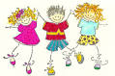

PSHE: Class rule display and take photos of ‘good’ behaviour. Circle times – my favourite…, talking about people in my family, how we can be kind etc.

Communication/Language: Talking and explaining what they did in Summer holidays.

PD: Toileting/Hygiene – take new photos – sequencing.

P.E – Shoes and socks. Introduce Hall and talk about rules/circle games

Maths: Number songs.

UtW: Talk about their family, their likes and dislikes.

Literacy: Exploring mark making through continuous provision

Art and Design: Modelling the creative area/Individual photos for class display/Singing songs. Collages/Portraits of ourselves.

ICT: Turn taking on class computer/iPad

**Key Texts**: **Harry and the Dinosaurs Go to School**

**ON ENTRY ASSESSMENTS.**

**Ourselves/All About Me**

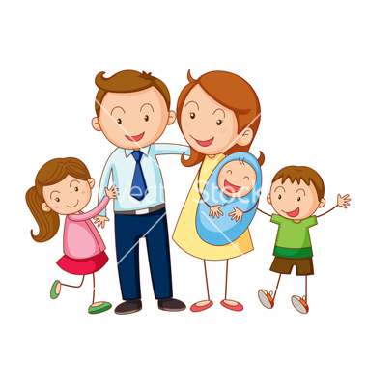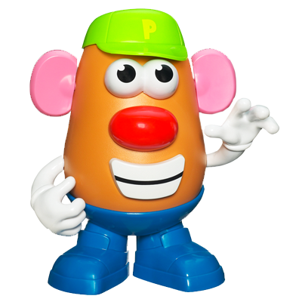

PSHE: What makes me special/unique. What do children want to be when they are older?

Communication/Language: Listening on carpet/Sharing ideas.

PD: Fine and gross motor activities, pencil control and games.

Maths: Making our own class number line. Number assessments. Measuring height and ordering. Maths about me: I have x brothers and sisters, I am x tall, my feet are size, my house number is x.

UtW: My family and pets. Looking at our skeleton and body. Use magnifying glasses to explore fingerprints, skin, hair etc. Look at pictures of themselves as a baby and guess who it is. Changing from babies to elderly.

Literacy: Writing guess who clues about themselves and others to guess who it is (CL link). Name writing. Labelling my house. Describing ourselves.

Art and Design: Making finger print family tree – writing names of family members. Designing ourselves (Bassatt Allsort man and describing words around it ‘I am ...). Colour mixing to match our eyes, hair, skin – make our own special colour wheel. I am Special songs. Make ourselves with potatoes. Making faces using different shaped crisps – skips, hoops etc. Vegetable faces with mashed potato as base.

ICT: Drawing my house/family.

**Key Texts: The Large Family Collection**

MC900281179[1]

**All about me**

**Rabbit**

**Autumn Term 1**

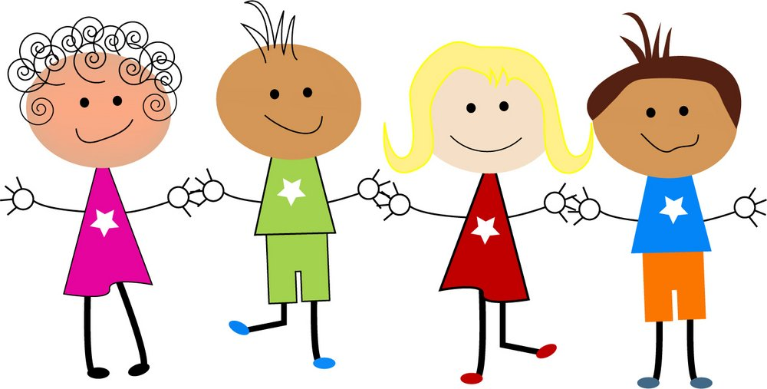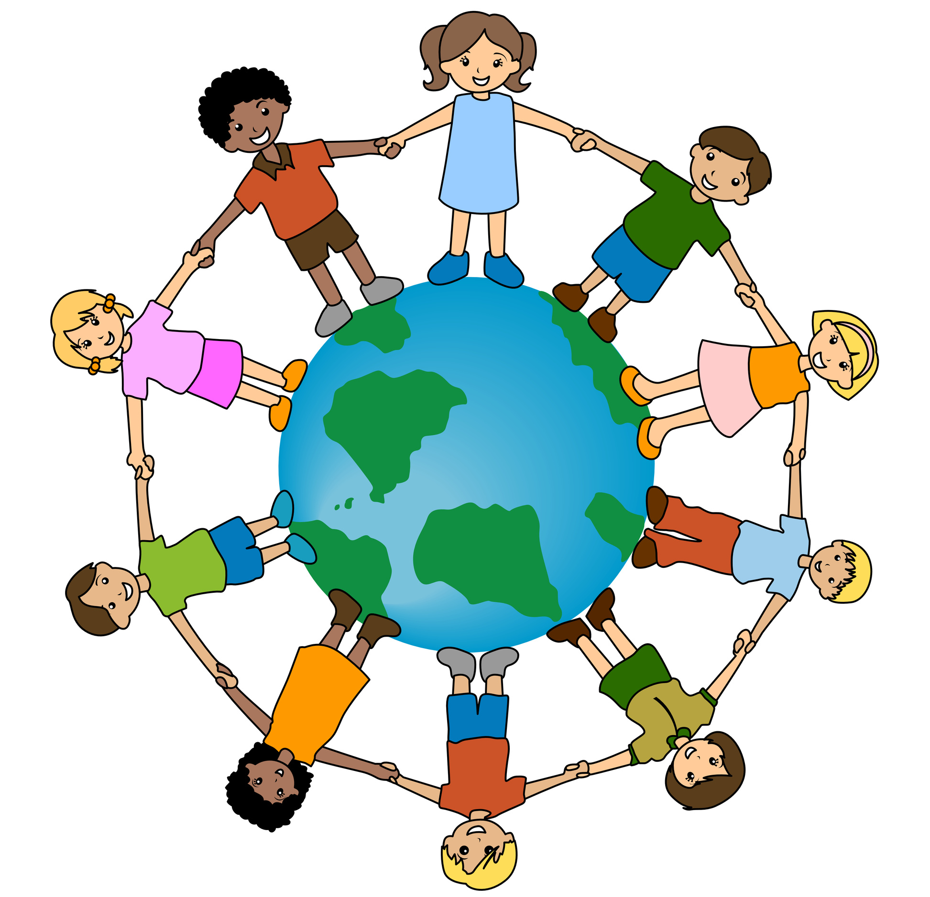

**It’s Good to be me! Similarities and Differences**

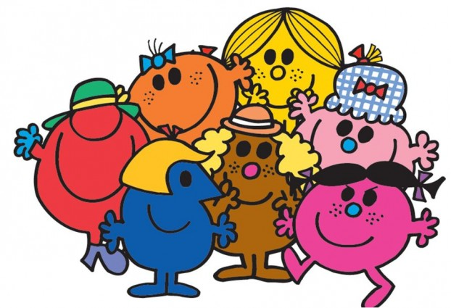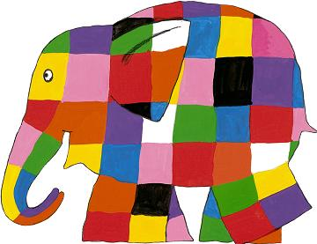

PSHE: Why/How are we different?

Communication/Language: Guess who – taking photos of children’s features and guess who it is. Mr Men – how are they same or different?

PD: Fine and gross motor activities, pencil control/Games

Maths: Sorting into pairs/groups, counting teeth, hands and feet. Shoes and socks. Comparing size. Number voting score on glasses!

UtW: Brushing teeth – Looking after ourselves. Healthy Eating – tasting foods.

Art and Design: Finger print name writing. Making funny faces with features from magazines and labeling. Making playdough faces and labeling. Footprints. Making glasses – glasses fashion show! Song: One finger one thumb.

Literacy: Instructional writing on how to get ready for school – sequencing photos. How to wash face/hands.

ICT: Using the mouse pad on the computer

**Key Texts: The Hueys in The New Jumper**,  **Elmer & Mr Men**

Phonics overview

(whole class)–

Recapping on Phase 1.

Phase 2 – Introducing and recapping over sounds and letter names/Letter formation.

Role Plays:

Home corner

School