**Physical Development with Spiderman:**

This sticky spider web activity is perfect for [indoor play](https://handsonaswegrow.com/indoor-activities-toddlers/), and can be done in any doorway or hallway using painters tape. Have some spidey target practice by throwing balls of newspaper.

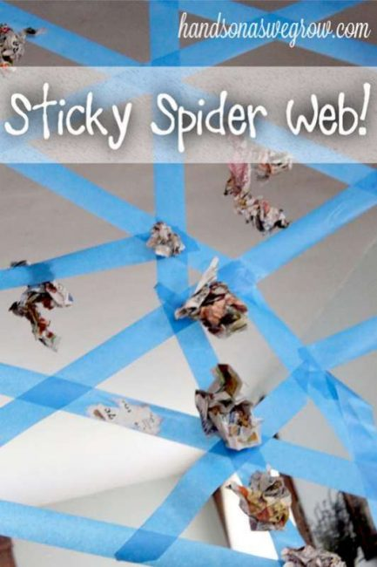

**Maths:**

Counting backwards to blast off in your superhero rockets.



**Understanding of the World:**

Science for superheroes – try the rainbow milk experiment. Please find the instructions on the back.



**Heroes**

Home School Learning

Sharing Date: 26th March

Please remember that these are suggestions, you can adapt these ideas and be as creative as you wish.

**Art and Design:**

Create your own super hero. What is their name? What special powers do they have?

**Literacy:**

Invisible writing. Write in white crayon and then paint over it with watered down paint so that it shows up.