Choose one project (or create your own similar homework project) to bring to school at the end of the term.

**English/ Art** – Imagine you are an evacuee during World War Two. You could write a letter home from this evacuee, a diary entry on the day they are evacuated and use a shoebox to create a model of the things an evacuee during this time would have packed.

**History** – create your own timeline to show the significant events during World War Two.

**English** – find out about a significant/ famous or inspirational person from World War Two. Create a biography about this person. This could be an information page, book, poster, Powerpoint or video clip.

**Science/ Computing –** Practise designing and testing your own plane/ vehicle design by using the following website

<http://www.physicsgames.net/game/Test_Pilot.html>

Take some screenshots of your work and print these to show your different designs and achievements.

***Battle of Britain***

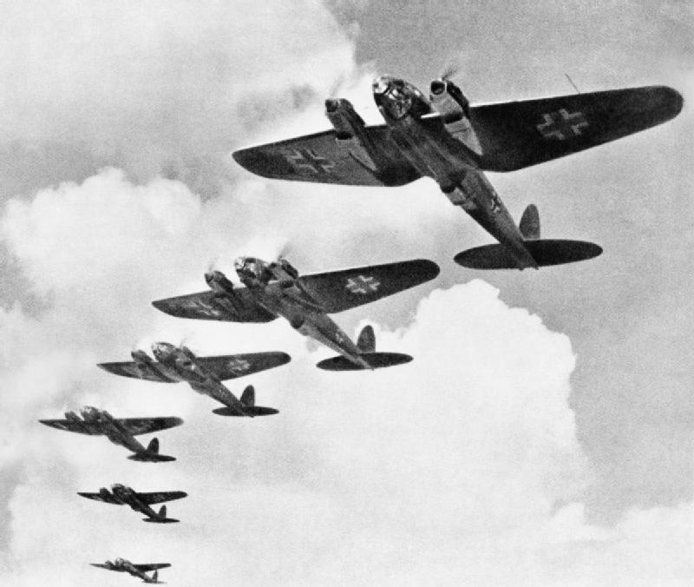

Owls Class Homework

Autumn Term

**Geography** – show on a map the countries involved during World War Two. Can you show the Allies and Axis in different ways? Can you label the countries and show their flags, as well as capital cities?

**Maths** – learn how to use coordinates to play Battleships. Create your own game board, divider and ships to play this with a partner.

**Other Things You Could Do (and bring a photo, written description or souvenir)**

Visit a museum and carry out your own research, for example:

* The 100th Bomb Group Memorial Museum in Diss;
* Dad’s Army Museum in Thetford;
* Imperial War Museum in Duxford;
* City of Norwich Aviation Museum in Norwich;
* Suffolk Regiment Museum in Bury St Edmunds.

..or further afield…

* Imperial War Museum in London;
* Cabinet War Rooms in London;
* Battle of Britain Museum in Kent;
* Bletchley Park in Milton Keynes,
* Ramsgate Tunnels in Kent;

**PE** – What games did children play during World War Two? Learn one of these, practise it and be ready to teach others!

**DT** – find out what rations people were allowed during World War Two. Can you design a weekly meal plan using these rations?

**PSHE** – ‘Never in the field of human conflict was so much owed by so many to so few.’ Winston Churchill.

This is a famous quote about the Battle of Britain. What do you think this means?

What other quotes can you find that are powerful/ inspirational or significant? Create a poster to display your quotes and explanations of these.